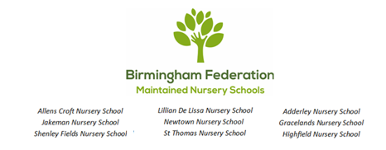

Charging and Remissions
St Thomas Centre Nursery
and
Day Care 2023

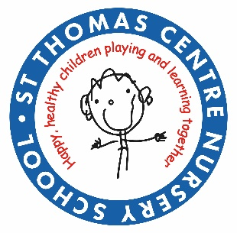

The Birmingham Federation of Maintained Nursery Schools follow the policies and procedures from Birmingham City Council and Birmingham Safeguarding Children Board (BSCB) which includes the Government's Prevent Strategy.

Version: Autumn 2023
Ratified by the Governing Body:
Signed by the Governing Body:
To be reviewed (annually): Autumn 2024

Charging and Remissions Policy Statement

Rationale
The Governing Board of the Birmingham federation of Maintained Nursery Schools recognises the valuable contribution that the wide range of additional activities, including trips, clubs and residential experiences can make towards pupils' education.

The Governing Body aims to promote and provide such activities both as part of a broad and balanced curriculum for the pupils of the school and as additional optional activities.

Context
The law states that education provided during school hours must be free. This definition includes materials, equipment and transport provided in school hours by the Local Authority or the School. No pupil may be left out of an activity because their parents cannot or will not make a contribution of any kind.

Aims
- To make school activities accessible to pupils regardless of family income.
- To provide a process which allows activities to take place at a minimum cost to parents, pupils and the school and;
- Which acknowledges the cost of such activities to the school’s budget.

Charges
The governing body reserves the right to make a charge in the following circumstances for activities organised by the school:

- Residential Activities Taking Place Largely During School Hours
- The full cost to each pupil of board and lodging. Parents have the right to claim free activities if they are in receipt of the following state benefits:
- Income Support
- Income based Job Seekers Allowance
- Support under section VI of the Immigration and Asylum Act 1996
- Working tax credit and an annual income that does not exceed the published Inland Revenue threshold

Activities Outside School Hours
The full cost to each pupil of all approved activities deemed to be optional extras that are not a necessary part of the national curriculum.

Individual Instrumental Tuition
The full cost to the pupil for providing any instrumental tuition if the cost is not an essential part of the national curriculum or examination syllabus.

Remissions
There will be no obligation for any parent to make a voluntary contribution towards the cost of school activities and to the School Fund. Pupils will not be treated differently whether or not their parents have made a contribution.

The Governing Board may wish to remit in full or in part the cost of other activities for particular groups of parents, for example, in the case of family hardship. When arranging a chargeable activity such parents will be invited in confidence for the remission of charges in full or in part. The Head Teacher in consultation with the Chair of Governors will make authorisation for such remission.

Voluntary Contributions
Voluntary contributions may be requested from parents/ carers to cover the cost of the following activities:

- cost of materials
- bus fares
- entrance fees
- school visitors
- healthy snacks

General
The Governing Body may from time to time, amend the categories of activity for which a charge may be made. Nothing in this policy statement precludes the Governing Body from inviting parents to make a voluntary contribution towards the cost of additional activities, which take place in school time. Parents may be advised that the continuance of an activity may depend upon voluntary contributions, but once it has been decided to run such an activity no qualifying child will be excluded on the grounds of voluntary contributions.

Daycare Provision
Our daycare and wraparound provisions (before/ after school and ‘holiday club’) charge for all additional activities in order to recover the full costs.

Parent / Carer Groups
We may charge a nominal fee to parents/ carers for attendance at our groups (stay and play etc.) Some groups may be run on our site by (Governing Board approved) third party providers and charge their own fees for doing so.

